**Please Create Another 5 Object-Oriented Examples and Give All Their Properties and Instances?**

**SUBMISSION**

1. Use graphics to show the examples.
2. Use Word Documents and attached the file to your GitHub
3. Submit before 24 Mac (Wednesday) at 8.00 am.

1. Class : Cat

Properties : ears, a tail, colour, paws, claws, body, eyes, coat

Instances : MyCat



2. Class : Smartphones

Properties : touchscreens, speaker, embedded memory, QWERTY keyboard,

camera, brands

Instances : MySmartphones

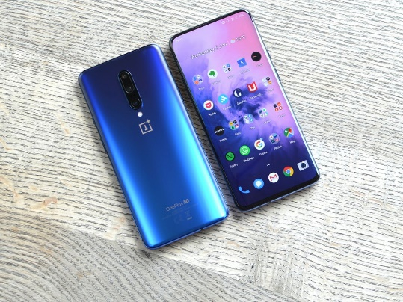

3. Class : Television

Properties : screen, speakers, remote control, model, brand, channel

Instances : MyTelevision

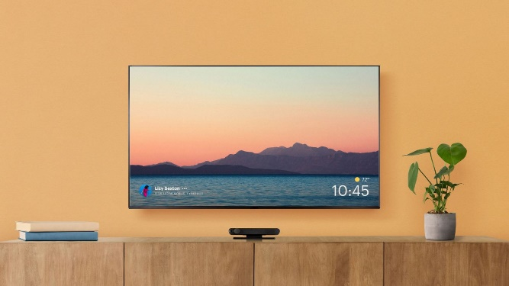

4. Class : House

Properties : Windows, door, roofs, cement walls, cement floor, furniture, electricity

and water supply

Instances : MyHouse



5. Class : Bird

Properties : feather, bill, wings, legs, eyes

Instances : MyBird

